KHQ  
**Internal Workflow**

# **Media Files**

1. Preferred image should be a minimum of 350 pixels wide and .PNG format.
2. Allowed file types include: PNG, JPG, GIF, MP3, MP4
3. All questions can have media files. See limitations below.

**Media Files for Multiple Choice Questions:** only 1 image is allowed per question and it will display below the question text. Images are not allowed for the answer options.

**Media Files for True-False Questions:** only 1 image is allowed per question and it will display below the question text. Images are not allowed for the answer options.

**Media Files for Flash Cards:** 2 images are allowed per question; one image on the front-side of the flash card and the 2nd image on the backside of the flash card.

1. Save media files to the author’s ShareRoom folder. The name(s) of the media files should identify which question they go with. Meaning, the name of the file listed next to the question in the spreadsheet should match the name of the actual media file.

File name as it appears in a file folder:

Copy of spreadsheet:

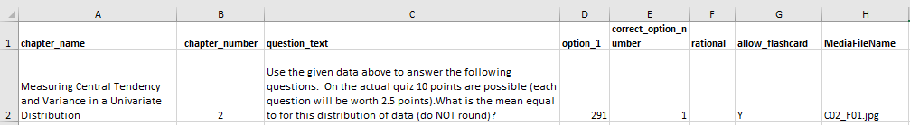

1. The name of the ShareRoom folder that you saved the media files to needs to be included in the Service ticket submitted.

# **Question Template**

**Additional details found in the Customer Instructions document.

1. The spreadsheet consists of four tabs, outlined in detail below.
2. Please do not make any modifications to the spreadsheet, including, but not limited to:
   * Change any of the column headings
   * Add any new columns to any of the spreadsheets/tabs
   * Add or remove spreadsheets, including creating separate spreadsheets for individual chapters.
3. If Existing Course:
   * The spreadsheet should only include new questions/material.
   * If there are existing questions that need to be updated, then question data should be added to the spreadsheet with a note to indicate they are not new questions. These updated questions should also be noted as a comment in the ticket. (A basic comment like: there are 3 questions in the spreadsheet that are existing and need to be modified).
   * If there are existing questions/material that needs to be deleted, then the data should be added to the spreadsheet with a note indicating the action requested. This requested action should also be noted as a comment in the ticket. (A basic comment like: there are 2 questions in the spreadsheet that are existing and need to be deleted).

**Currently there is no way to update questions that already exist, except manually, one-by-one.

**If questions/material are deleted, all user data for those questions on the ‘Results’ page and ‘Struggling With’ sections will be deleted.

## Question Formatting

1. Math Equations/Formulas:
   * IF equations are complex with ratios, and take up multiple lines, then the equation should be saved and uploaded as an image, for each question or flash card.
     + Example: The text “Simplify completely:” could be included as part of the image, or entered as text for the question on the spreadsheet.



* + IF equations are written in a simple format, then the equation can be added to the spreadsheet using html code, when applicable.
    - Example: 3*x* + 2*y* = 11 would be written like this: 3<i>x</i> + 2<i>y</i> = 11
    - To allow for carriage returns us the html code for line break <br/>

1. Equations with Exponents:
   * Use html code <sub> for subscript or <sup> for superscript.
   * 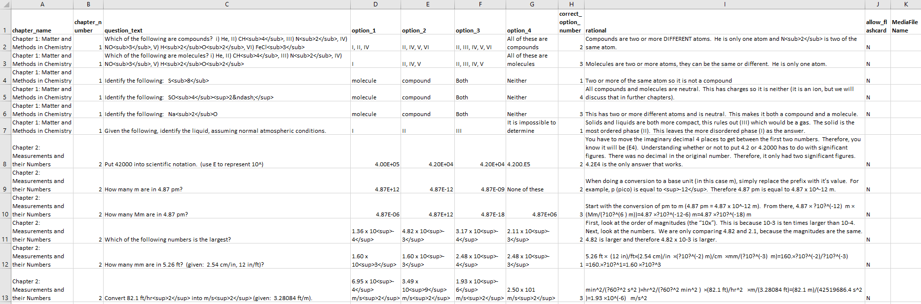Example: how to write the Question Text and Rationale when there are exponents being used
2. Questions with one scenario/word problem used for multiple questions
   * If a set of questions contains one word problem or scenario to be used for multiple questions, then that text needs to be entered into the question field for each question individually.
     + 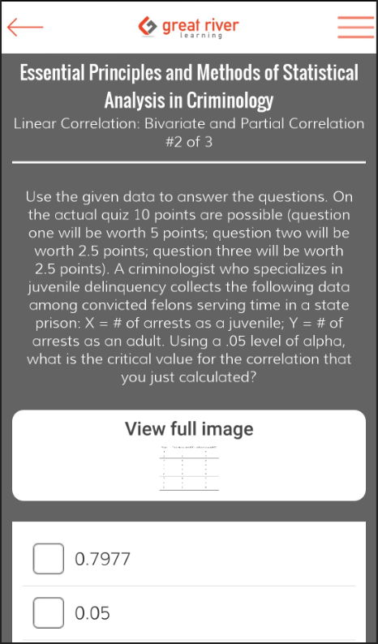Example: The below paragraph of text applies to multiple questions, so it is added to the spreadsheet as question text. The answer options and image for each question is what is unique.

# **Sending Service Ticket to IT**

**WORKFLOW:**

1. Email khq@kendallhunt.com and attach the spreadsheet of questions 🡪 Service Desk ticket is created.
   * Use the email template below.
2. If *new* course, IT will create the course in KHQ app. Then questions are uploaded.
3. If *existing* course, IT will add/edit/delete questions per ticket instructions.
4. Any requested Access Codes will then be generated; attached to Service Desk ticket; and ticket sent back to sender.

** Access Codes will not be generated *until* the questions have been uploaded to the app.

**Email Template:**

SUBJECT: KHQ- New Course/Questions Upload OR KHQ – Update Course/Questions Upload

BODY:

Author Name – [Called “Contributor Name” in the app and on spreadsheet]  
Publication – [Please provide the name as you would like it displayed in the app]  
ISBN –   
Launch Date – [Date the app is needed by]  
New or Existing Course in App – [Indicate if the course is existing in the app or if it is a new course]

1. Please create this new course in the KHQ app using the attached questions.
2. Please upload Access Codes to HE website; or attach *x* number of codes to be added to printed books.
3. Please provide X number of demo access codes for the author.
4. Please have questions uploaded and access codes sent by mm-dd-yy.